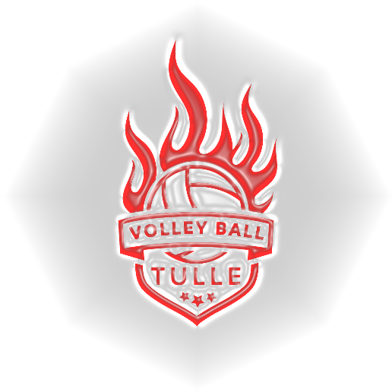

**Créneaux horaires gymnases VTN :**

|  |  |  |  |  |  |  |
| --- | --- | --- | --- | --- | --- | --- |
|  | ***Lundi*** | ***Mardi*** | ***Mercredi*** | ***Jeudi*** | ***Vendredi*** | ***Samedi*** |
| ***CCS*** |  | **18h-20h**  ***M18 G*** | **18h- 20h**  ***M18 F (A et B)*** |  |  |  |
| ***Victor Hugo*** | **20H30 -22H** |  |  |  | **18h30 - 20h30**  ***M18 G***  ***M18 F (A)***  ***M18 F (B)*** | **13h30 -15h30**  ***M15 G-F***  ***M13 G-F***  ***M11 G-F*** |
| ***Turgot*** |  | ***19h30-21h30***  ***Loisir adulte*** |  | **18h-20h**  ***M15 G-F***  ***M13 G-F*** |  |  |
| Edmond |  |  |  |  |  | 13h30-15h30 si match à VH |